SAN DIEGO SEND-OFF
Friday, March 29th, 2024

If you are receiving this email, it is because you are a client and/or friend of the La Jolla Private Wealth Group of Wells Fargo Advisors. The idea behind the San Diego Send-Off is to keep you abreast of interesting trends we are seeing in the market/world.

Best Regards,

Robert Palatella Michael O’Brien Josh O’Brien, CFP®, SE-AWMA™ Melanie Gilmore, CRPC®, AWMA®
Managing Director Private Wealth Financial Advisor Senior Vice President Financial Advisor Senior PIM Managing Director Josh.obrien@wfa.com Melanie.gilmore@wfa.com
Portfolio Manager Senior PIM
Robert.palatella@wfa.com Portfolio Manager
Michael.j.obrien@wfa.com

La Jolla Private Wealth Group: 2024 Forbes Best-In-State Wealth Management Teams. Source: Forbes.com. 2024 Forbes Best-in-State Wealth Management Teams: Awarded January 2024; Data compiled by SHOOK Research LLC based on the time period from 3/31/22-3/31/23. Fee paid for use of marketing materials. The Forbes Best-In-State Wealth Management Teams rating algorithm is based on the previous year’s industry experience, interviews, compliance records, assets under management, revenue and other criteria by SHOOK Research, LLC. Investment performance is not a criterion. Self-completed survey was used for rating. This rating is not related to the quality of the investment advice and based solely on the disclosed criteria. Fee paid for use of logo.

The Fed expects interest rates to return to lower levels, albeit at a slower pace than previously anticipated
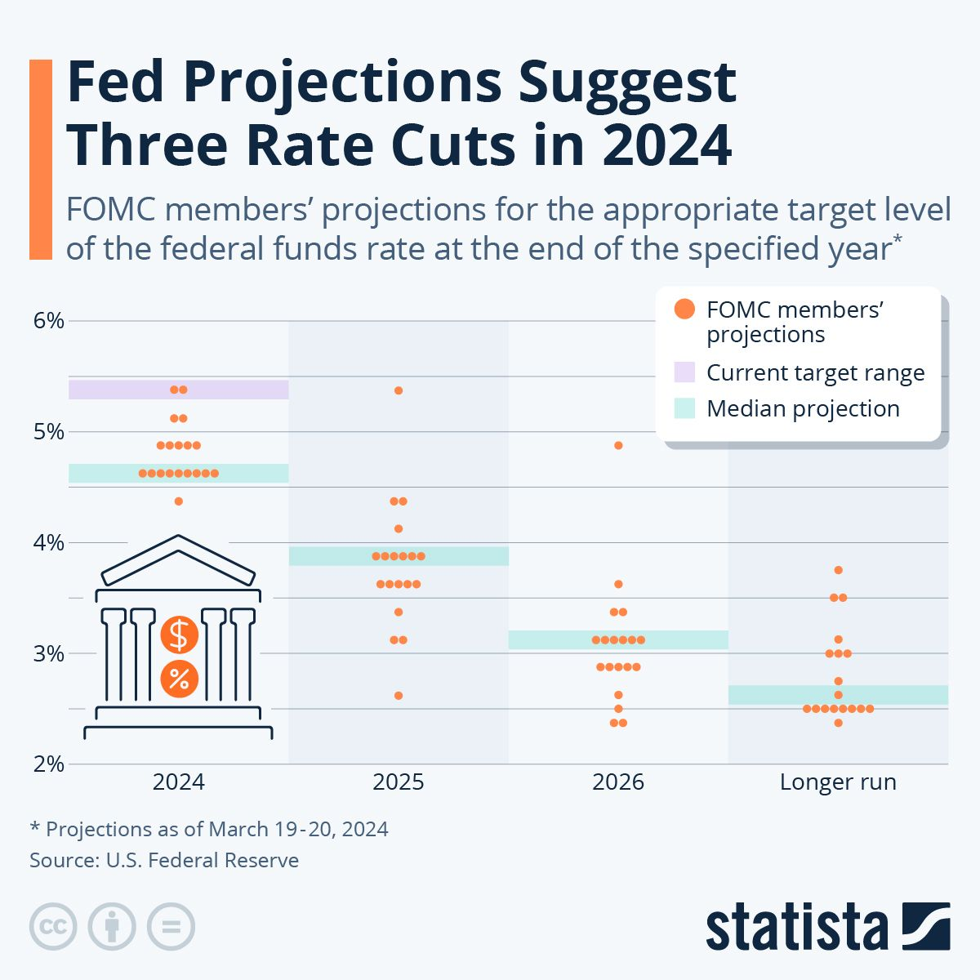
It took just 57 days for Bitcoin ETFs to surpass $50B in assets under management (AUM)
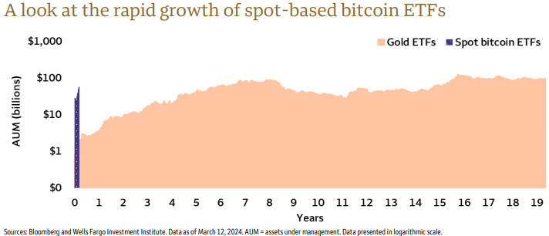

As obesity rates rise in the U.S., new weight-loss drugs have surged in popularity
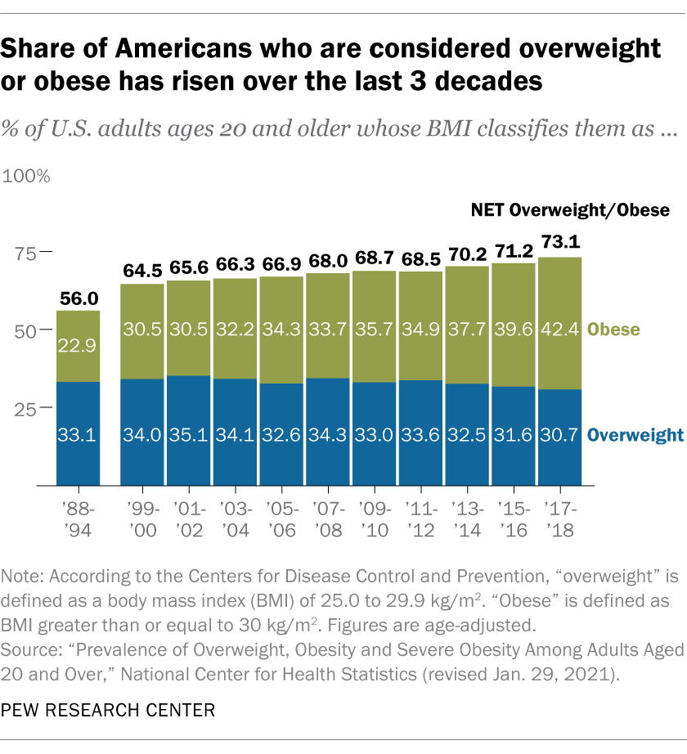
High nominal interest rates have tended to contribute to lower price-to-earnings (P/E) multiples

Sources: Bloomberg and Wells Fargo Investment Institute. Monthly data from January 1, 1963 to December 31, 2023. Inflation data as of November 30, 2023. The average price to earnings was calculated using the S&P 500 index from 1963 – December 2023. The S&P 500 Index is a market-capitalization-weighted index considered representative of the U.S. stock market. Inflation represented by the Consumer Price Index. The Consumer Price Index measures the average price of a basket of goods and services. An index is unmanaged and not available for direct investment. Past performance is no guarantee of future results.

We expect IPO activity to pick up further in 2024
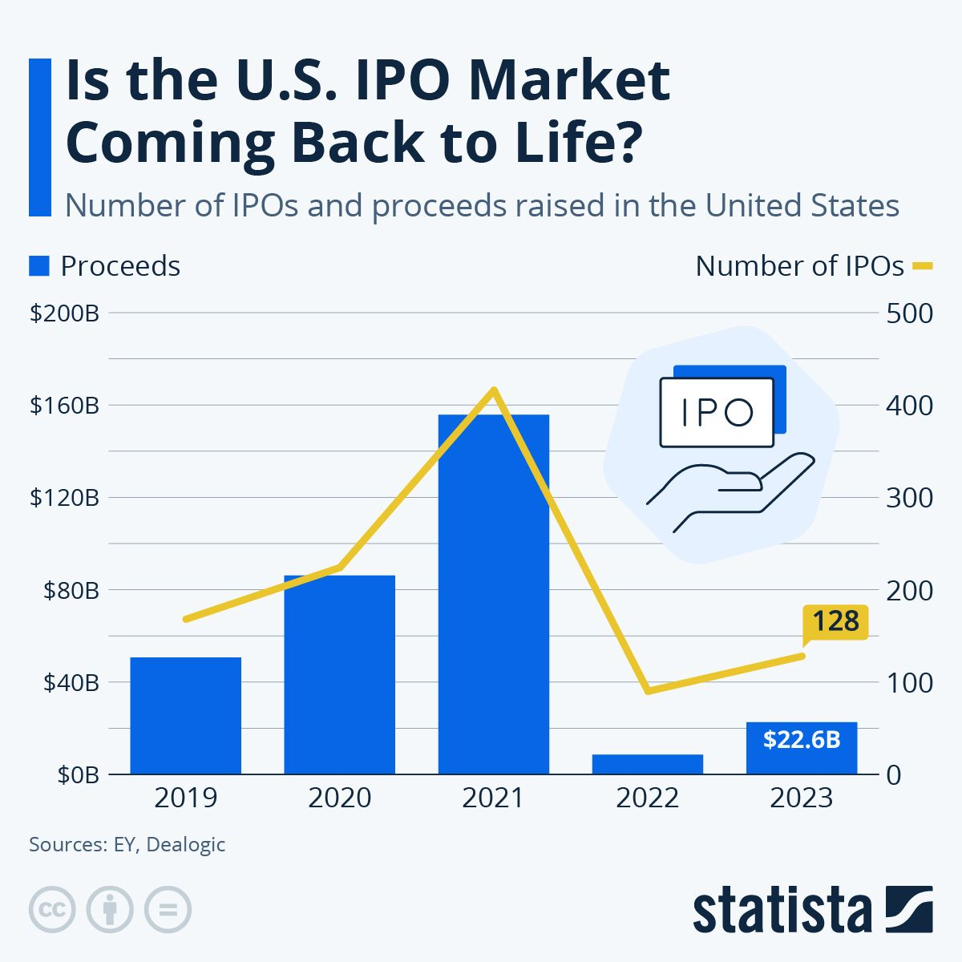
In 2023, the U.S. produced 28% more oil than Russia and 33% more oil than Saudi Arabia
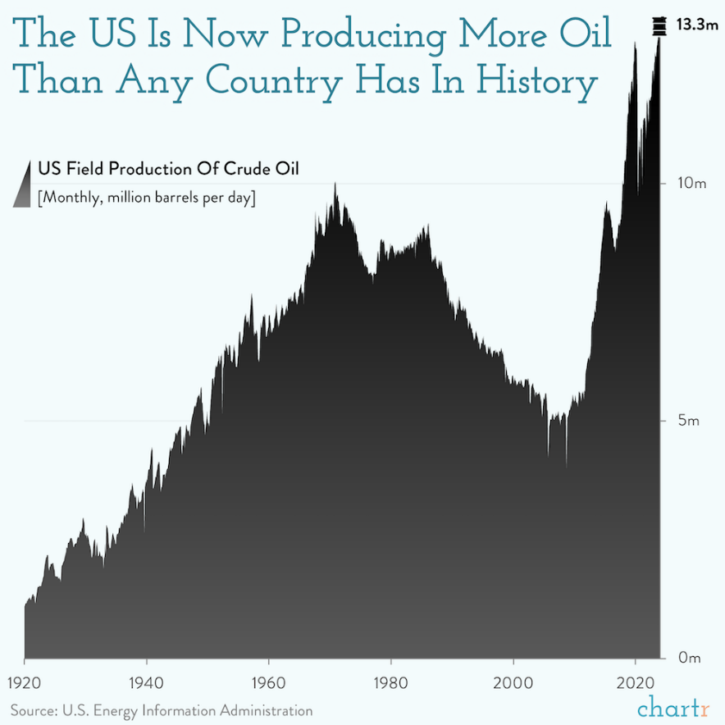

Despite the production upswing, the # of crude oil rigs has fallen by about 1/3 versus 10 years ago
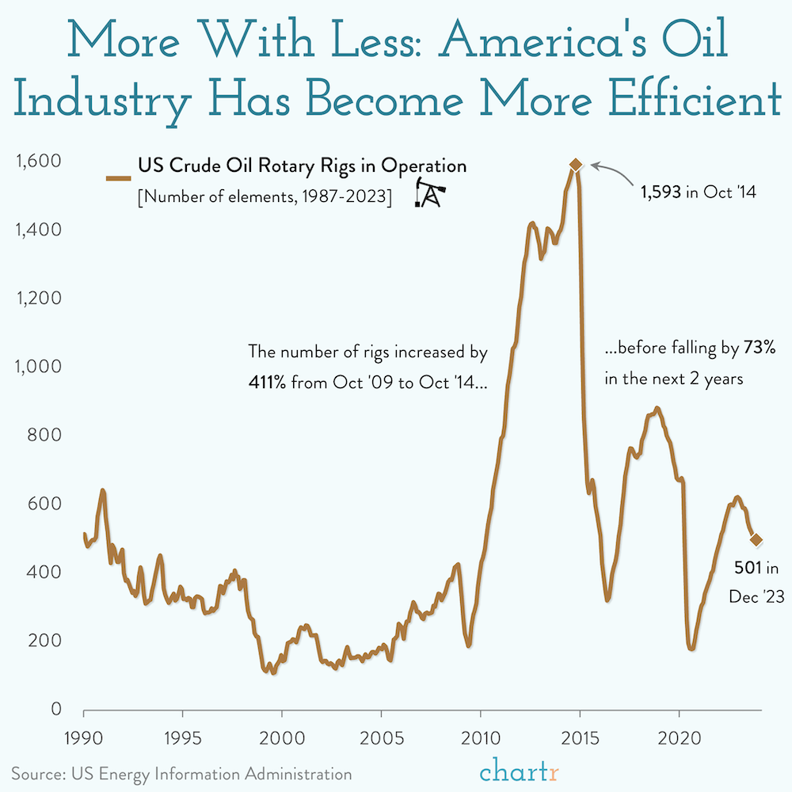
The Bank of Japan’s decade-long fight against deflation has resulted in near-zero returns at home, forcing Japanese investors to move their money abroad, often to the United States.
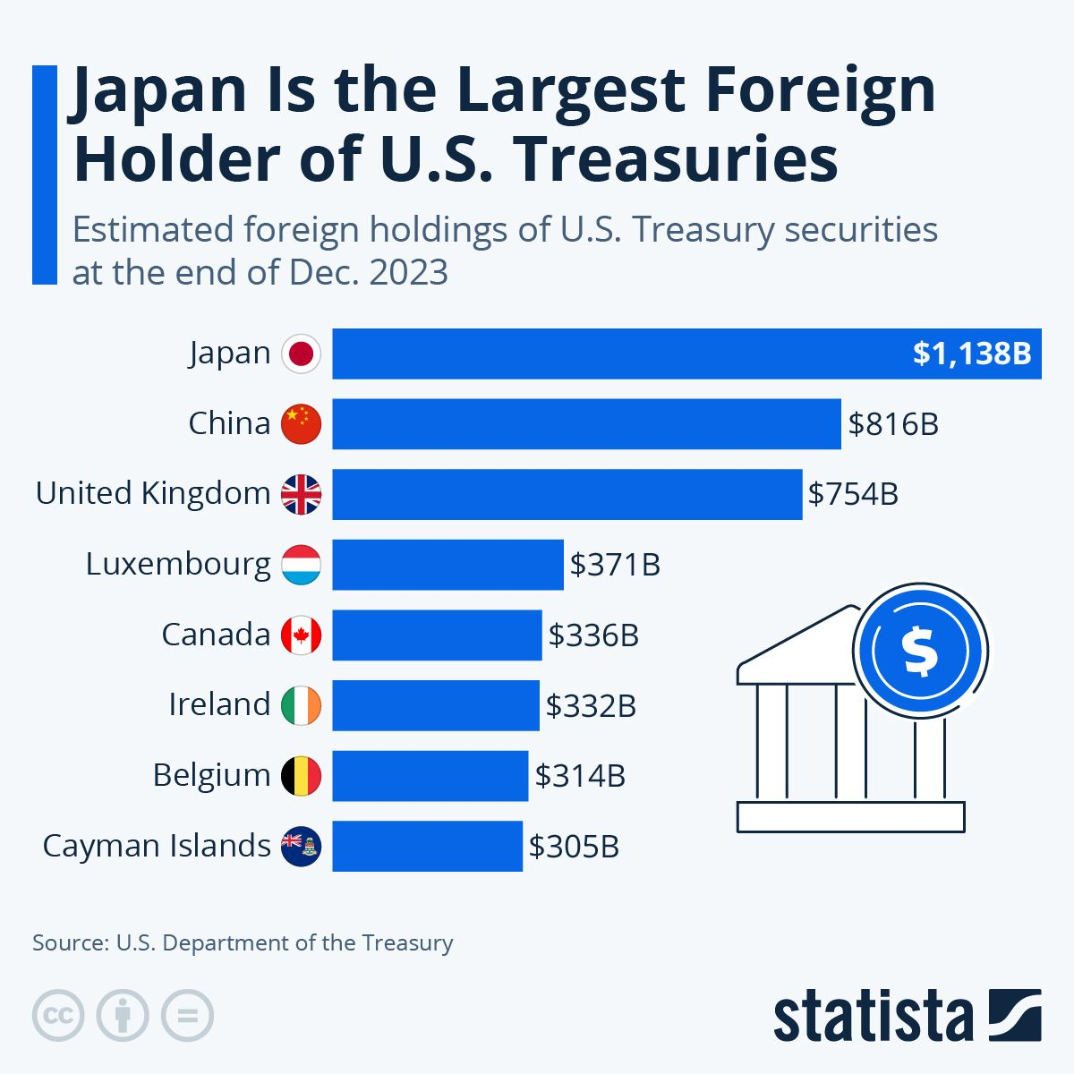

Finding a potential balance between risk and reward

Sources: © 2023 – Morningstar Direct, All Rights Reserved¹, and Wells Fargo Investment Institute. Data from January 1, 2009 to December 31, 2023. Performance results for Moderate Growth and Income Liquid are calculated using blended index returns and is for illustrative purposes only. Moderate Growth & Income allocation is dynamic and changes as needed with adjustments to the strategic allocations. Index returns do not represent investment performance or the results of actual trading. Index returns reflect general market results, assume the reinvestment of dividends and other distributions, and do not reflect deduction for fees, expenses or taxes applicable to an actual investment. Unlike most asset class Indexes, HFR Index returns are net of all fees. Because the HFR Indexes are calculated based on information that is voluntarily provided actual returns may be lower than those reported. An index is unmanaged and not available for direct investment. Past performance is no guarantee of future results. Standard deviation is a measure of the volatility of returns. The higher the standard deviation, the greater volatility has been. See following pages for the blended index composition, risks and definitions of indexes.
¹ All Rights Reserved. The information contained herein: (1) is proprietary to Morningstar and/or its content providers; (2) may not be copied or distributed; and (3) is not warranted to be accurate, complete or timely. Neither Morningstar nor its content providers are responsible for any damages or losses arising from any use of this information.

Idaho, Florida, South Carolina, and Texas have grown populations 4.3% to 6.2% since 2020
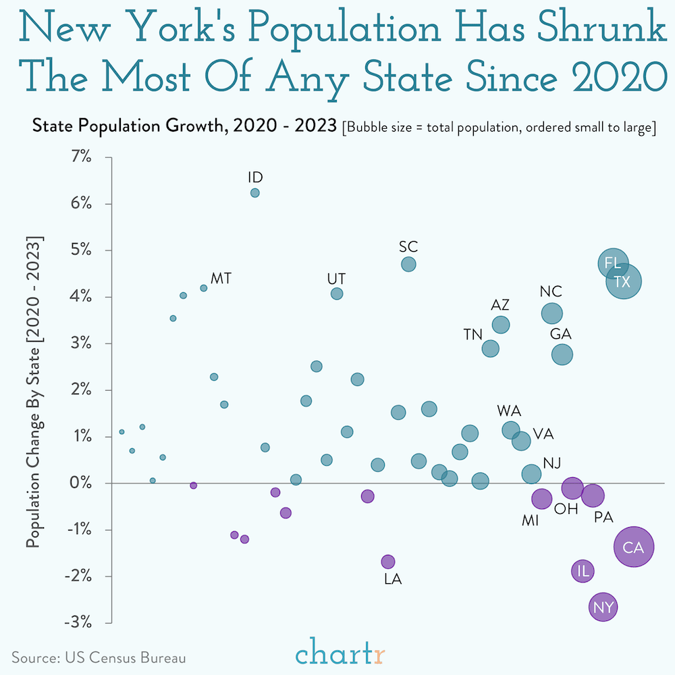
Articles of the month:

Teaching kids about money
Click Here to Read

20 lessons from 20 years of managing money
Click Here to Read

The opinions expressed here reflect the judgment of the author as of the date of the report and are subject to change without notice. The material has been prepared or is distributed solely for information purposes. Please note that we are not responsible for the information contained on the listed web site(s). The site(s) is/are provided to you for informational purposes only.

